QF627 Programming and Computational Finance

HWS0305: Data Manipulation and Visualization

(part 2)

**In all the Python programs, we assume students will import Matplotlib, Pandas, Numpy and Scipy as the following:**

**import matplotlib.pyplot as plt**

**import pandas as pd**

**import numpy as np**

**import scipy.stats as ss**

Q1. (Python) Complete the following code **with one command** to add a column to **data** using the first row of **data**, and name this column **f**.

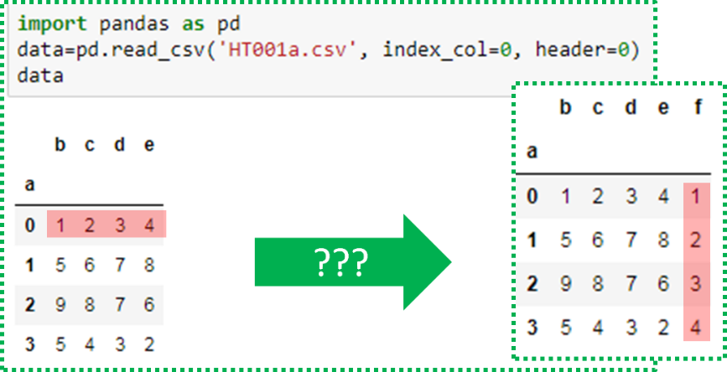

Q2. (MATLAB) Complete the following code **with one command** to add a column to **data** using the first row of **data**, and name this column **f**.

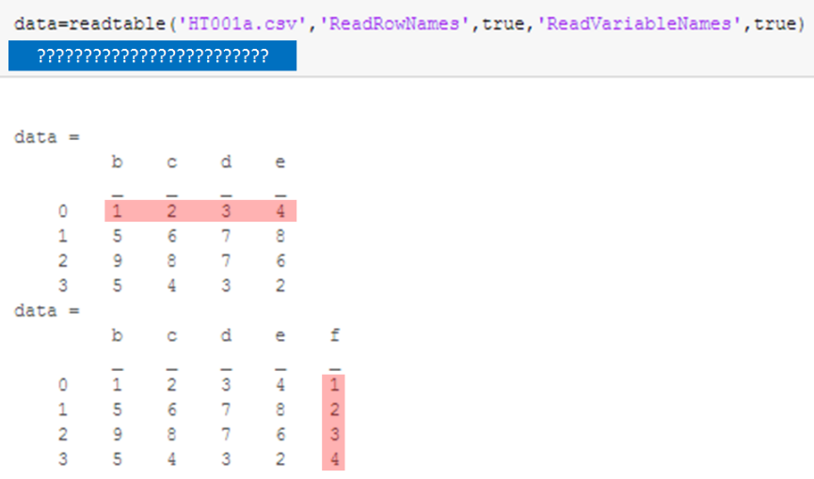

Q3. (Python) Follow the instructions to complete the computation.

|  |
| --- |
| 1. **Use one command** with the Pandas library function **pandas.read_csv** to load data from the CSV file, **dataset01.csv**, using the first row as column names. Name the data as **data**. |
|  |
| 2. Define a function, **option_BS**, which computes and returns the European call option price using the following formula: $$c=S∙e^{-q∙T}∙Φ\left(d_{1}\right)-K∙e^{-r∙T}∙Φ\left(d_{2}\right)$$ where $d_{1}=\frac{\ln\left(\frac{S}{K}\right)+\left(r-q+\frac{σ^{2}}{2}\right)T}{σ\sqrt{T}}$ and $d_{2}=d_{1}-σ\sqrt{T}$ |
|  |
| 3. **Use one command** with the Pandas library function **pandas.DataFrame.apply** to compute the European call option price for each row of **data** and add the results to **data** as a new column, and name this column as **BS**. |
|  |

Q4. (MATLAB) Follow the instructions to complete the computation.

|  |
| --- |
| 1. **Use one command** to load data from the CSV file, **dataset01.csv**, using the first row as column names. Name the data as **data**. |
|  |
| 2. Define a function, **option_BS**, which computes and returns the European call option price using the following formula: $$c=S∙e^{-q∙T}∙Φ\left(d_{1}\right)-K∙e^{-r∙T}∙Φ\left(d_{2}\right)$$ where $d_{1}=\frac{\ln\left(\frac{S}{K}\right)+\left(r-q+\frac{σ^{2}}{2}\right)T}{σ\sqrt{T}}$ and $d_{2}=d_{1}-σ\sqrt{T}$ |
|  |
| 3. **Use one command** with library function **rowfun** to compute the European call option price for each row of **data** and add the results to **data** as a new column, and name this column as **BS**. |
|  |